VQEG and ITU-T SG12 Q13, 14, 17 Meeting Invitation, March 2019, Berlin

Dear Colleagues (Delegates),

Deutsche Telekom AG, Strategy & Technology Innovation(S&TI) has the pleasure of inviting you to the Video Quality Expert Group (VQEG) meeting and the ITU-T Study Group 12, Question 13, 14 and 17 meeting in Berlin.

The two meetings will take place, at:

Deutsche Telekom AG („Telekom Innovation Arena“)
Winterfeldtstraße 21
D-10781 Berlin

The VQEG meeting starts on Monday 4th March 2019, 9:00 hours and ends Friday 8th March 2019, 14:00 hours.

The ITU-T SG12 Q13, Q14, Q17 meeting starts on Tuesday (5th March 2019, 9:00) and ends on Thursday (7th March 2019, 18:00 hours).

Meeting location and general information will be provided in the following pages.

We look forward to seeing you in Berlin.

Sincerely,

Dr. Bernhard Feiten
VTI, S&TI-NAB, Senior Expert

Meeting Registration
The registration for the VQEG meeting is at the Web site of VQEG.
Delegates, only attending the ITU-T meeting, should announce their participation via E-mail.

Meeting Venue

Deutsche Telekom AG, Winterfeldtstraße 21, Berlin, 7th floor, room 7074
- Wireless LAN will be provided.
- Time Zone, CEST
- Voltage, 230 V, be sure you have the correct adapter.

For any questions about the meeting please contact:
- Bernhard Feiten, bernhard.feiten@telekom.de, +491715635834
- Sandra Knauth, sandra.knauth@telekom.de

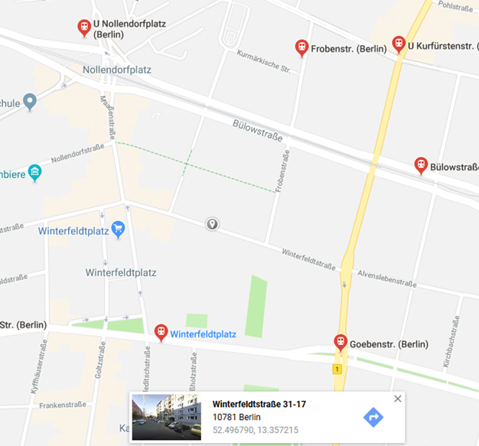

Transportation
How to reach Deutsche Telekom, S&TI at Winterfeldtstr. 21 in Berlin ?
- For public transport look at https://fahrinfo.bvg.de/.

Example for coming via Airport Tegel:
Public Transport: Bus X9, Direction „Zoologischer Garten“, leave „Ernst-Reuterplatz“ ->
Underground U2 – Direction “Pankow”, leave at “Nollendorfplatz”, (ca. 40 min., 2,80€)
Taxi: 24 minutes, 32 €

Example for coming from Airport Schoenefeld:
Public Transport: Bus X7 or 171, Direction “U Rudow”, leave at “U Rudow”
U-Bahn U7, Direction “Rathaus Spandau”, leave at “Kleistpark”, change to
Bus 187 Direction “U Turmstraße”, leave at “Goebenstraße", (ca. 60 min., 3,10€ )
Taxi: 32 minutes, 40 €

Accommodation

Deutsche Telekom, S&TI is not responsible for Hotel reservation. Please contact the hotel directly to make your reservation and any changes. We advise to book your hotel as soon as possible.

Find below a list with hotels and their distance to Winterfeldtstr. 21

- www.hotel-potsdamerinn.com, 0,2 km,
- www.hotel-michele.de, 0,26 km
- https://www.novum-hotels.de/hotel-aldea-berlin, 0,3 km
- https://www.novum-hotels.de/hotel-cityb-berlin, 0,4 km
- https://lindemannhotels.de/hotel-berlin/lindemanns/, 0,4 km
- http://hotel-sachsenhof-berlin.de, 0,7 km
- www.ambiente-berlin.com, 0,7 km
- http://residenz-begaswinkel.de/, 0,8 km
- http://www.hotel-berlin.de/de/, 0,9 km
- http://quentindesign.com/, 0,95 km
- https://www.accorhotels.com/de/hotel-9068-mercure-hotel-berlin-zentrum/index.shtml , 1,0 km
- http://www.goldentulipberlin.de/de, 1,1 km
- http://www.sylterhof-berlin.de/, 1,1 km
- https://lindemannhotels.de/hotel-berlin/fjord-hotel-berlin, 1,1 km
- http://www.altberlin-hotel.de/, 1,2 km
- http://www.riu.com, 1,2 km
- http://www.esplanade.de , 1,3 km
- https://www.accorhotels.com/de/hotel-4988-mercure-hotel-berlin-mitte/index.shtml 1,6 km

Visa Information

PLEASE NOTE: LETTERS MAY TAKE SOME DAYS TO BE PROCESSED.
LET US KNOW, IF HARD COPIES OF THE LETTERS WOULD BE REQUIRED.
OTHERWISE, WE WILL SENT THE LETTERS VIA EMAIL ONLY.

Please contact Sandra Knauth (email: sandra.knauth@telekom.de) or Bernhard Feiten
(E-mail: bernhard.feiten@telekom.de) with reference to VQEG/ITU-SG12Q44 meeting if you require a personal letter of invitation for a visa application.

Your email must include the following information (and any other information you need in the letter) in order for it to be processed:

- Family name (last name):
- Forename (first name):
- Birth date (month/date/year):
- Passport number, date and place of issue, expiry date:
- Gender:
- Company name:
- Postal Code:
- Country:

PLEASE VERIFY THAT ALL INFORMATION IS ACCURATE AND WILL BE VALID AT THE TIME OF THE MEETING.

